This is a Admin page we can simply give User-id and paasword then login.It has an access of all seller’s and fertilizers.

FARMER PORTAL

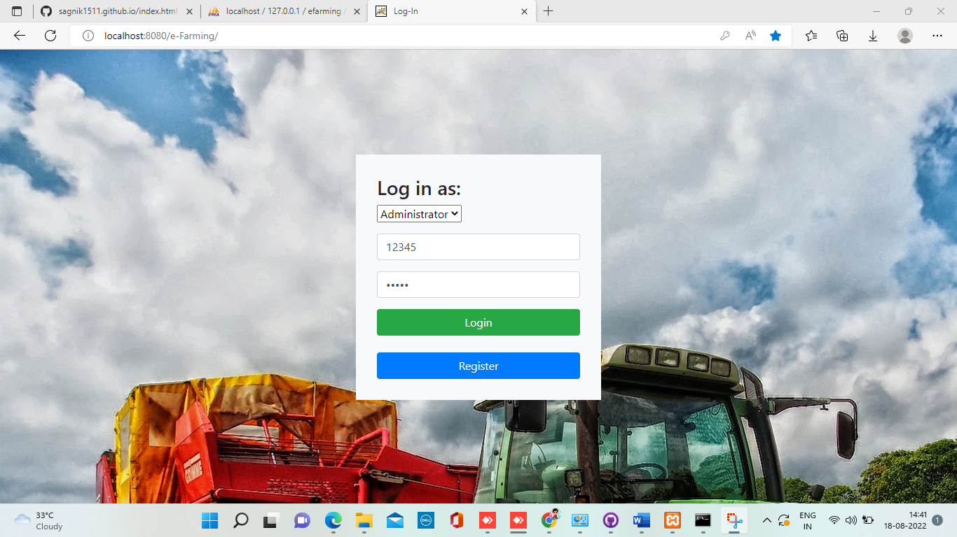

After login the admin profile will open in which the account id, phones names, and many credential are there

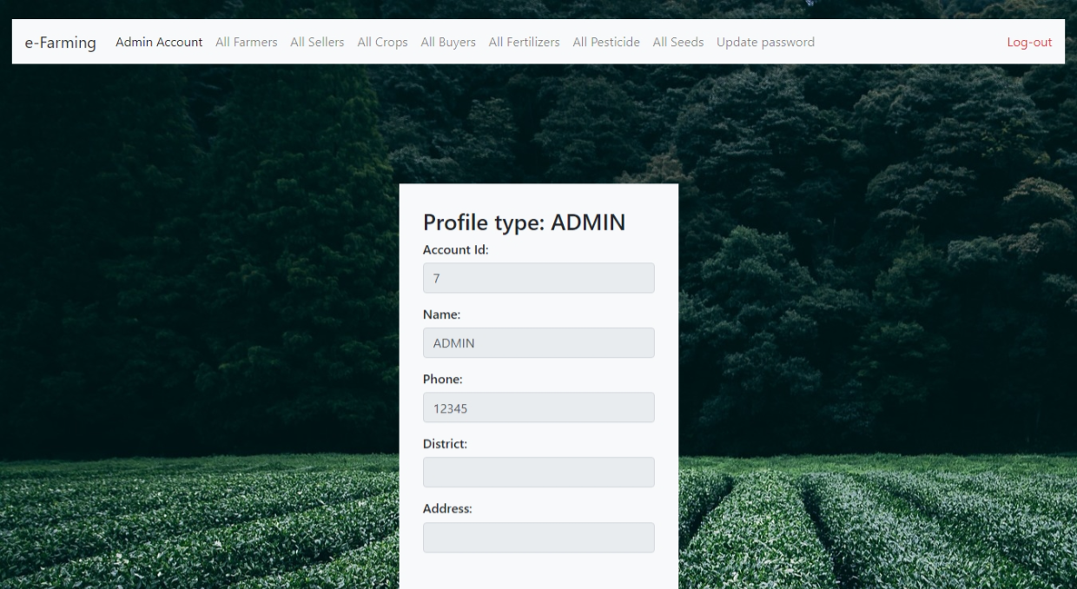

Here Admin can see all the farmers details.

Here admin can see all the Sellers.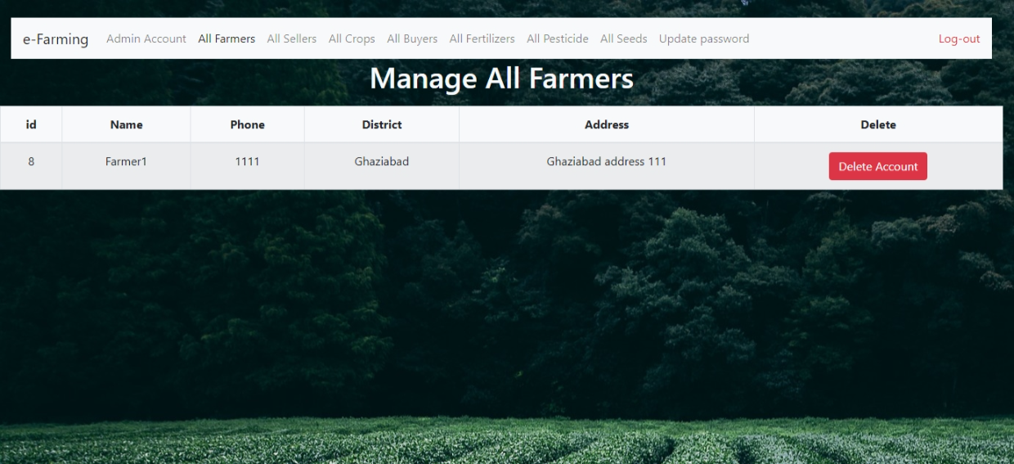

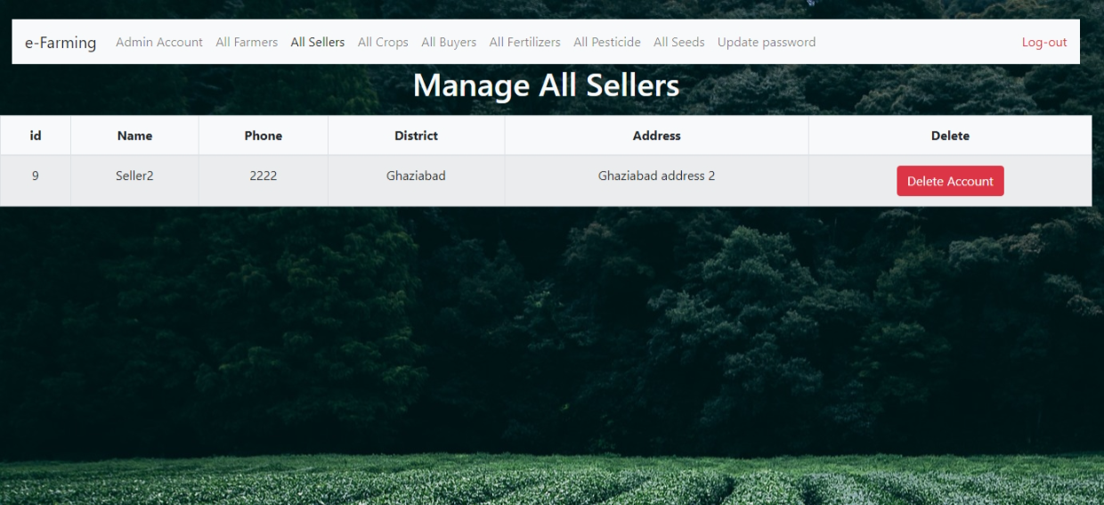

Here Farmer can see who have uploaded their crops which are available for sale.

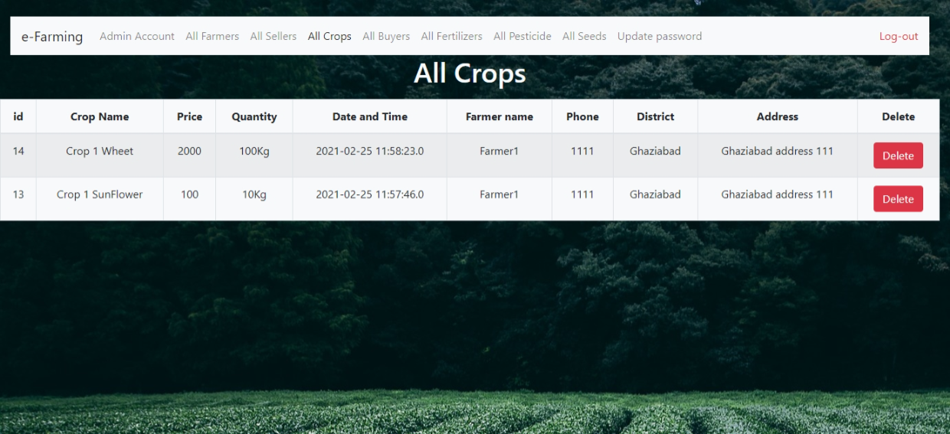

Fertilizers can register on this portal and check the credential and connect with the seller and farmer.

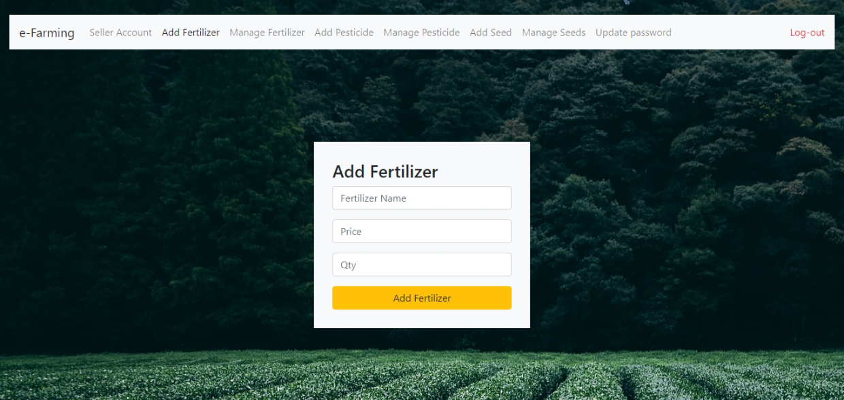

Here Admin can check price and quality details of the crops and can check the expiry date of crops.

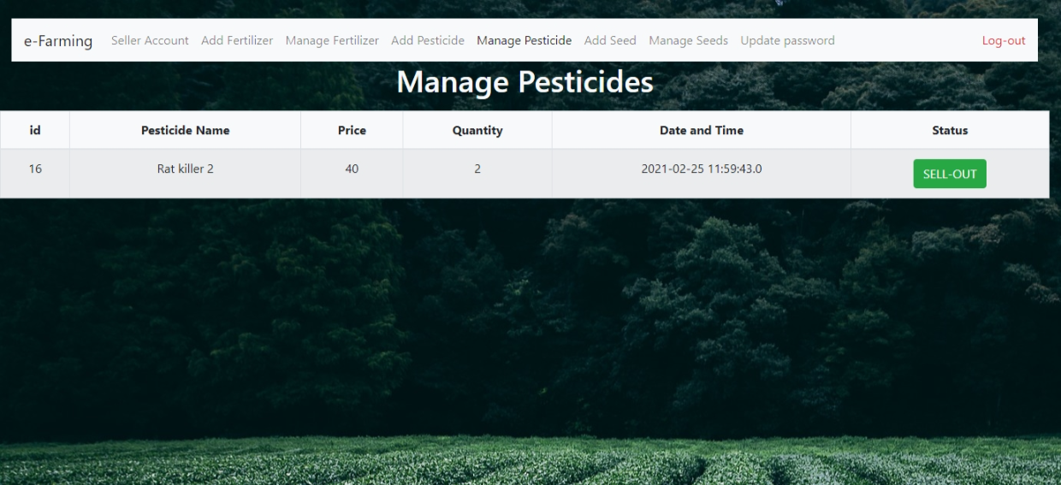

Here Admin and all the users can easily update the password.

